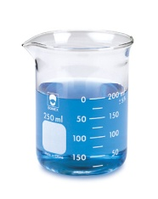
Name: _______________________________________________ Date: ________________________ Blk: ____
Ch.13 Properties of Solutions
By the end of the unit, I will be able to:
Section | Learning Outcomes | Stoplight After
Sec. 13.1, 13.3 and 13.4 | - Describe the energy changes that occur in the solution process in terms of the solute-solute, solvent-solvent, and solute-solvent attractive forces; describe the role of disorder in the solution process
 | - Rationalize the solubilities of substances in various solvents in terms of their molecular structures and intermolecular forces
 | - Describe the effects of pressure and temperature on solubilities
Sec. 13.2 | - Define mass percentage, parts per million, mole fraction, molarity, molality, and calculate concentrations in any of these concentration units.
 | - Convert concentration in one concentration unit into any other (given density of the solution where necessary)
Sec. 13.5 | - Determine the concentration and molar mass of a non-volatile non-electrolyte from its effect on the colligative properties of a solution.
 | - Explain the difference between the magnitude of changes in colligative properties caused by electrolyte compared to those caused by non-electrolytes.
 | - Describe the effects of solute concentrations on the vapour pressure, boiling point, freezing point, and osmotic pressure of a solution, and calculate any of these properties given appropriate concentration data.
Sec 13.6 | - Describe how a colloid differs from a true solution

Reflection:
I feel I need to focus my studying on….

