Name: _______________________________________________ Date: ________________________ Blk: ____

By the end of the unit, I will be able to:
Section | Learning Outcomes | Stoplight After
Sec. 26.1 | - List four groups of hydrocarbons and draw the structural formula from each group—in this case the alkanes.
 | - Write the formulas and names of the first 10 members of the alkane series.
 | - Write the structural formula of an alkane given its IUPAC name.
 | - Give an example of structural isomerism in alkanes.
Sec. 26.2 | - List the four groups of hydrocarbons and draw the structural formula of an example from each group –in this case as applied to alkenes and alkynes.
 | - Write the structural formula of an alkene or alkyne, given its systematic IUPAC name.
 | - Name an alkene or alkyne, given its structural formula.
 | - Give an example of structural and geometric isomerism in alkenes and alkynes.
 | - Give examples of addition reactions of alkenes and alkynes, showing the structural formulas of reactants and products.
 | - Explain why aromatic hydrocarbons do not readily undergo addition reactions.
 | - Give two or three examples of substitution reactions of aromatic hydrocarbons.
Sec 26.3 | - Identify the groups or arrangement of atoms in a molecule that correspond to the following functional groups: alcohols, ethers, aldehydes and ketones, carboxylic acids, esters, amines, and amides.
 | - Give examples of the condensation reactions to alcohols to form ethers, of alcohols and carboxylic acids to form esters, and of amines and carboxylic acids to form amides.
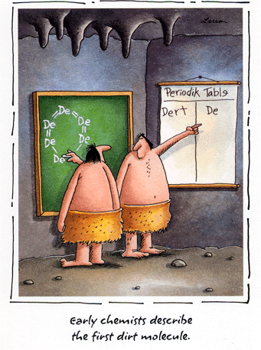
Reflection:
I feel I need to focus my studying on….

