MULTIPLE CHOICE QUESTIONS:

1. In the chemical reaction which can be represented by the equation
Sn_{(s)} + 2H₃O⁺_{(aq)} + H_{2(g)} → 2H₂O_{(l)} + Sn²⁺_{(aq)}
select the species which is oxidized

A. H₃O⁺_{(aq)}
B. H₂O_{(l)}
C. Sn_{(s)}
D. H_{2(g)}

2. Given the half-reaction expression,
MnO₄– + 2H₂O → 4OH– + MnO₂
which procedure will balance electric charge?

A. add 3 e– to the left side
B. add 3 e– to the right side
C. add 4 e– to the left side
D. add 4 e– to the right side

3. IO₃– is reduced to I– in basic solution. If the coefficient of IO₃– in the half-reaction equation is 1, the coefficient of OH– will be

A. 0
B. 2
C. 3
D. 6

4. A Co / Co²⁺ ll Ag⁺ / Ag couple has the overall equation,
Co_{(s)} + 2Ag⁺_{(aq)} → Co²⁺_{(aq)} + 2Ag_{(s)}
If the Ag⁺ / Ag half cell were diluted by adding pure water, the effect would be that

A. voltage would remain the same
B. voltage would increase
C. voltage would become zero
D. voltage would decrease

5. The oxidizing agent in a redox reaction is always the species which

A. loses electrons.
B. acts as a cathode.
C. becomes negatively charged.
D. decreases in oxidation number.
6. A student has been directed to oxidize iron to Fe²⁺ but not to Fe³⁺. A suitable choice for the oxidizing agent could be a solution containing

A. Zn²⁺_{(aq)}
B. Sn²⁺_{(aq)}
C. Ag⁺_{(aq)}
D. F–_{(aq)}

7. The oxidation number of S in S₂O₆^{2–} is

A. +5
B. +6
C. –6
D. +10

8. Consider the following diagram of an electrochemical cell:
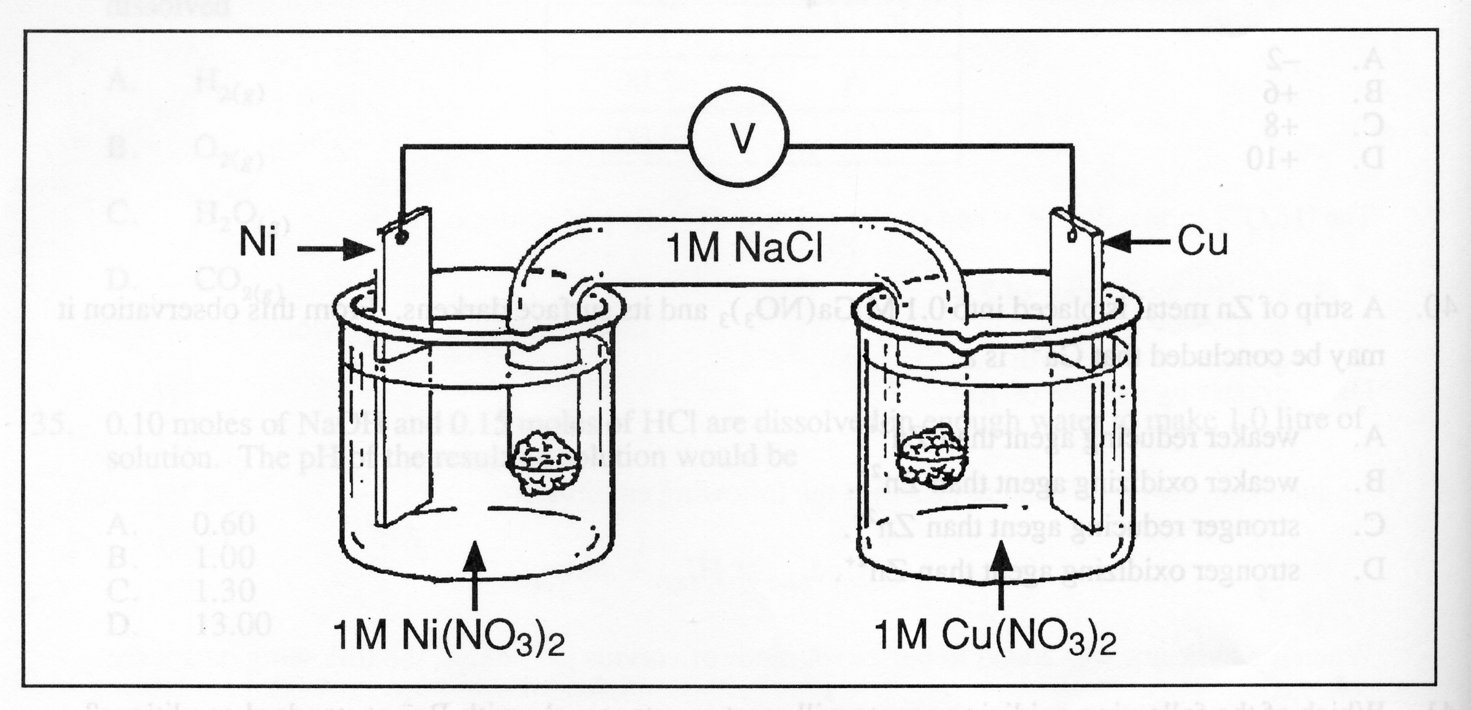
1.0 M Cu(NO₃)₂
Cu
1.0 M Fe(NO₃)₂
Fe

Data: Cu²⁺ + 2e–  Cu E° = +0.34 V
Fe²⁺ + 2e–  Fe E° = –0.44 V

In the electrochemical cell represented by the above diagram, the flow of electrons through the solid conductor could best be described as

A. the flow of electrons from the Cu electrode to the Fe electrode
B. the flow of electrons from the Fe electrode to the Cu electrode
C. the oscillation of electrons
D. the oscillation of electrons with simultaneous energy transformations

9. The copper produced in smelters contains many impurities. Which of the following procedures is used to produce almost pure copper?

A. The impure copper is the cathode of an electrolytic cell and pure copper forms on the
anode.
B. The impure copper is melted and centrifuged.
C. the impure copper is boiled and pure copper is condensed.
D. The impure copper is the anode of an electrolytic cell and pure copper forms on the cathode.

10. Consider the following diagram of an electrolytic cell.
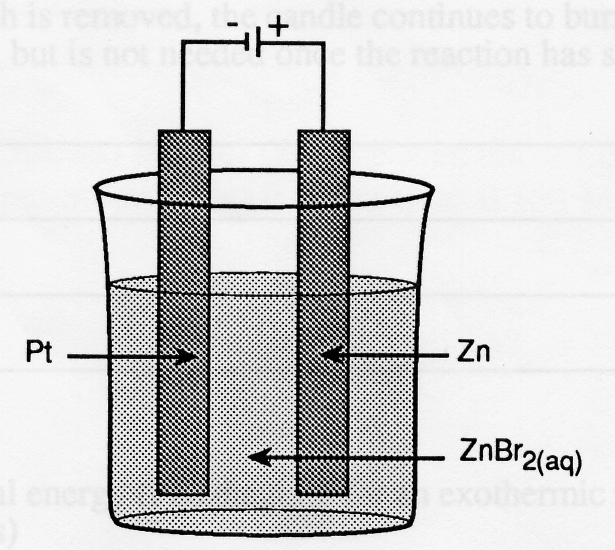
Fe
Cu
CuSO_{4(aq)}

The anion is

A. Cu²⁺
B. H₂O
C. SO₄^{2–}
D. Fe

11. Consider the following diagram of an electrolytic cell.
Fe
Ni
Ni²⁺ , SO₄²⁻, H⁺, OH⁻
Ni²⁺ , SO₄²⁻ , H₂O , H⁺ , OH⁻

Which one of the following statements is true regarding the movement of particles in the solution?

A. Ni²⁺ ions move towards the Fe electrode
B. Ni²⁺ ions move towards the Ni electrode
C. SO₄^{2–} ions move towards the Fe electrode
D. H⁺ ions move towards the Ni electrode

12. Consider the following diagram
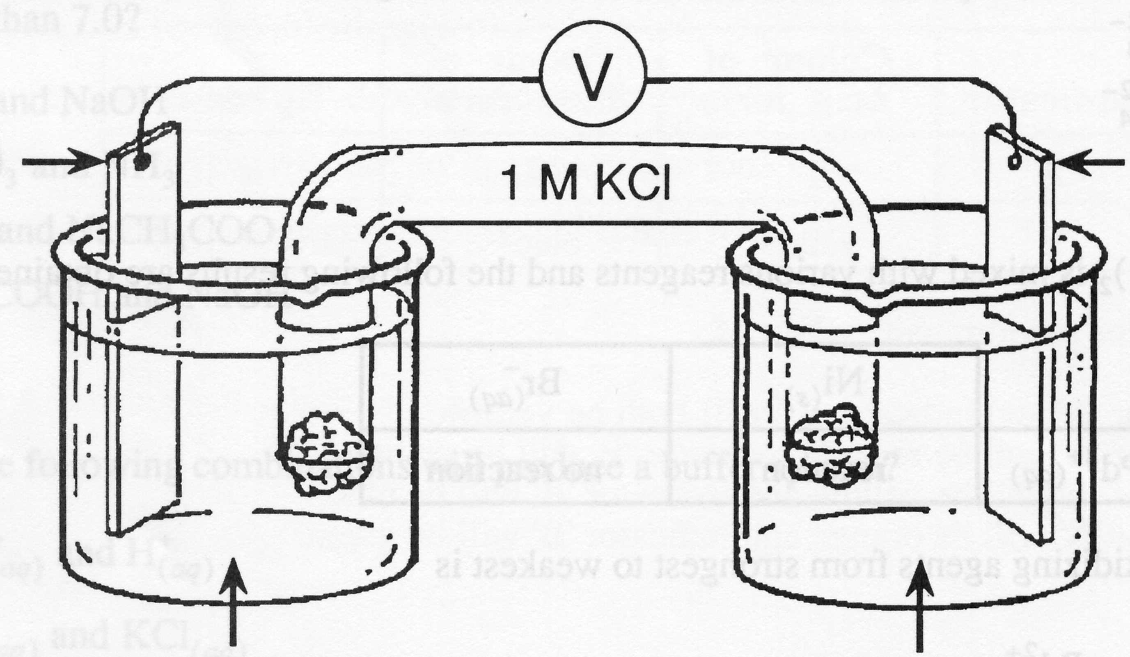
Co
1.0 M Zn(NO₃)_{2(aq)}
Zn
1.0 M Co(NO₃)_{2(aq)}

Which of the following best describes what occurs in the salt bridge?

A. The flow of electrons from the Zn half cell to the Co half cell
B. The two-way migration of ions
C. The flow of electrons form the Co half cell to the Zn half cell
D. The movement of Cl²⁺ towards the Zn half cell and the Zn²⁺ towards the Co half cell

13. What minimum voltage would be required for an electrolytic cell in which the reaction
desired is:
Fe²⁺ + Sn → Sn²⁺ + Fe?
(Assume 1 M solutions at a temperature of 25°C)

A. –0.59 V
B. –0.31 V
C. 0.31 V
D. 0.59 V

14. Arsenic forms 3 compounds containing chlorine: AsCl₃, AsCl₅, and AsOCl₃. What is the oxidation number of as in each of these compounds?

 | AsCl₃ | AsCl₅ | AsOCl₃
A. | –3 | –5 | –5
B. | –3 | –5 | –1
C. | +3 | +5 | +1
D. | +3 | +5 | +5

15. What change in the oxidation number of uranium occurs when pitchblende (U₃O₈) reacts with nitric acid to form UO₂(NO₃)₂, uranyl nitrate?

A. – 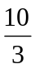
B. – 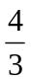
C. + 
E. +

16. Which of the following skeleton half-reactions are not oxidations?

I. ClO₃– → ClO₂–
II. C₂H₄ → C₂H₆
III. NO₂ → N₂O₄

A. I only
B. I and III
C. II and III
D. I, II and III

17. Which one of the statements below is incorrect, given the following equation for the
reaction that occurs when copper metal is dissolved in nitric acid?
3Cu + 2NO₃– + 8H⁺ → 3Cu²⁺ + 2NO + 4H₂O

A. Copper is being oxidized.
B. The product of the oxidation is NO.
C. The reducing agent is metallic copper.
D. Hydrogen’s oxidation number hasn’t changed.

18. Which one of the species below is losing electrons in the reaction
Hg²⁺_{(aq)} + H₂O_{2(aq)} → Hg_{(l)} + O_{2(g)} + 2H⁺_{(aq)} ?

A. Hg
B. Hg²⁺
C. H₂O₂
D. O₂

19. Which one of the following is the weakest reducing agent in the reaction
W + Y⁺  W⁺ + Y K = 10^{–35}

A. W
B. W⁺
C. Y
D. Y⁺
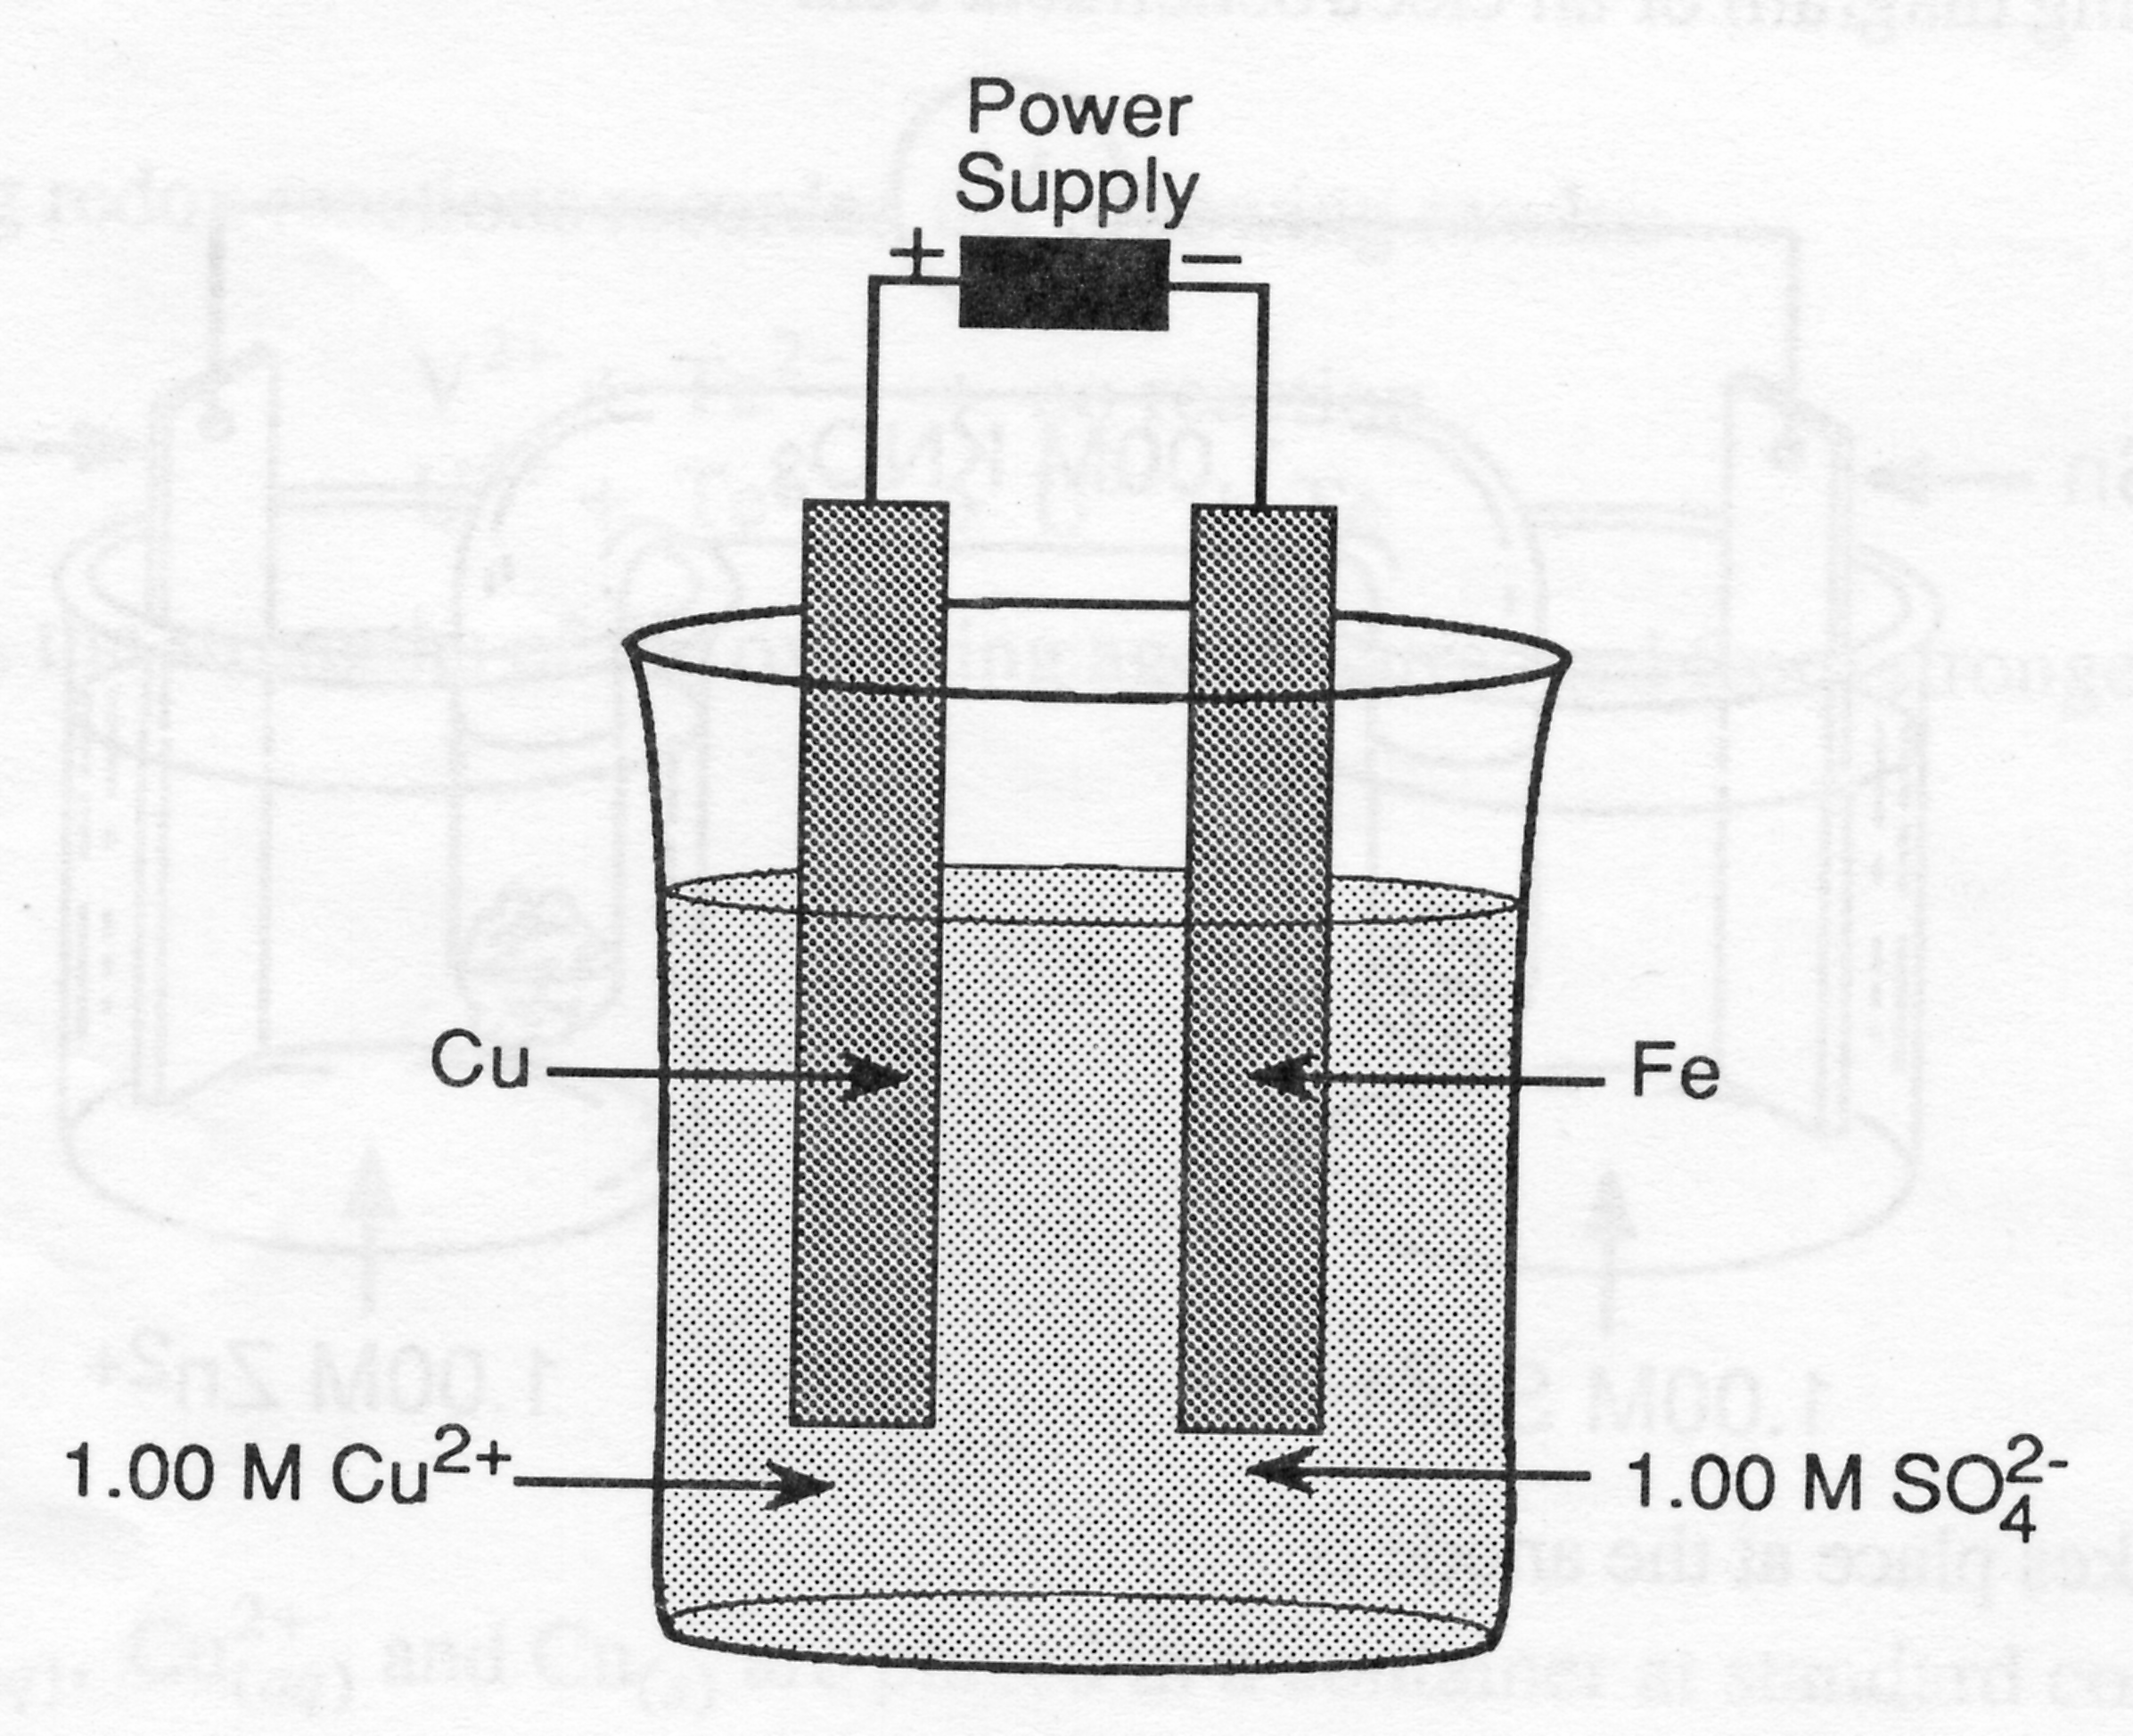
20. Consider the following diagram:

Which one of the following would be the cathode?

A. The Cu²⁺ ion.
B. The SO₄^{2–} ion.
C. The Fe electrode.
D. The Cu electrode.

Use the following information to answer questions 21 and 22.

An electrochemical cell has a strip of Zn dipping into 1 M Zn(NO₃)₂ in one half cell, and a strip of Ni dipping into 1 M Ni(NO₃)₂ in the other half-cell. A salt bridge connects the two half cells.

21. Which one of the following statements about the cell described above is INCORRECT?

A. The [Zn²⁺] will increase.
B. The nickel strip will lose mass.
C. Nickel (II) ions will migrate toward the nickel.
D. Electrons will flow from the zinc to the nickel.

22. If 0.500 mol of electrons flows in the cell described above, which one of the following statements is CORRECT?

A. The voltage of the cell will have increased.
B. The zinc strip will be 16.4 g greater in mass.
C. The nickel strip will be 14.7 g greater in mass.
D. The nickel strip will be 16.4 g greater in mass.

23. What would happen to the voltage of an operating cell (with over all equation
Cu²⁺ + Ni  Ni²⁺ + Cu) if pure water were added to the Ni²⁺/ Ni half cell?

A. The voltage would increase.
B. The voltage would decrease.
C. The voltage would remain constant.
D. The voltage would decrease at first, then slowly increase to the original voltage.

24. Which one of the following equations represents the cathode reaction in the manufacture of sodium metal by the electrolysis of liquid sodium chloride?

A. 2Cl– → Cl₂ + 2e–
B. Na⁺ + e– → Na
C. NaCl → Na⁺ + Cl–
D. 2H₂O + 2e– → 2OH– + H₂

25. In which one of the following substances does sulfur have the lowest oxidation number?

A. S₂O₃²⁻_{(aq)}
B. S₂O₈²⁻_{(aq)}
C. S₄O₆²⁻_{(aq)}
D. SO₃²⁻_{(aq)}

26. Which one of the following species is the strongest reducing agent?

A. Ba_{(s)}
B. Fe_{(s)}
C. Sn²⁺_{(aq)}
D. H₂O_{2(aq)}

27. Which one of the following species could be a product of a reaction where NO_{2(g)} acts as an oxidizing agent?

A. NO_{(g)}
B. N₂O_{5(g)}
C. NO₃⁻_{(aq)}
D. N₂O_{4(g)}

28. Which one of the following half-reactions is balanced?

A. IO₃⁻_{(aq)} + 6H⁺_{(aq)} + 5e⁻ → I_{2(s)} + 2H₂O_{(l)}
B. ClO⁻_{(aq)} + H₂O_{(l)} + 2e⁻ → Cl⁻_{(aq)} + 2OH⁻_{(aq)}
C. SO₄²⁻_{(aq)} + 8H⁺_{(aq)} + 6e⁻ → H₂S_{(g)} + 4H₂O_{(l)}
D. NO₂⁻_{(aq)} + H₂O_{(l)} + 2e⁻ → 2H⁺_{(aq)} + NO₃⁻_{(aq)}
29. Of the following metals, which would be the best one to use to make a container in which
to store an aqueous copper (II) sulfate solution?

A. Ag_{(s)}
B. Fe_{(s)}
C. Ni_{(s)}
D. Pb_{(s)}

Use the following diagram to answer questions 30 and 31.
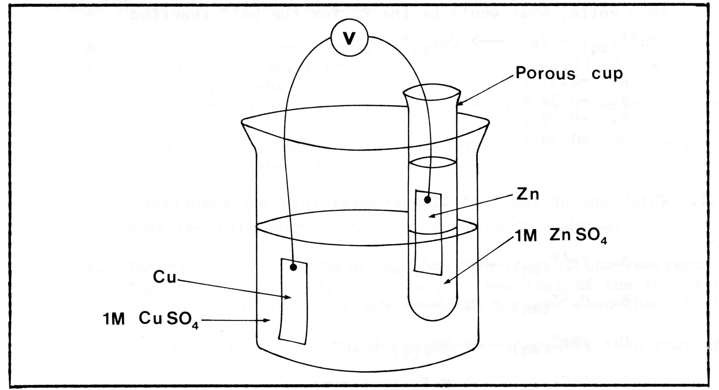

30. What is the voltmeter reading for the electrochemical cell shown above?

A. 0.34 V
B. 0.42 V
C. 0.76 V
D. 1.10 V

31. Which one of the following actions takes place during the operation of the above cell?

A. Zinc ions are produced at the zinc electrode.
B. Cu_{(s)} is oxidized to Cu²⁺_{(aq)} at the copper electrode.
C. Electrons flow from the copper electrode to the zinc electrode.
D. SO₄²⁻_{(aq)} migrates from the zinc half-cell to the copper half-cell.

32. If the E° for the half-reaction Ni²⁺_{(aq)} + 2e⁻ → Ni_{(s)} were set at zero volts, what would
be the E° for the half reaction:
Cu²⁺_{(aq)} + 2e⁻ → Cu_{(s)} ?

A. −0.60 V
B. −0.34 V
C. +0.08 V
D. +0.60 V

33. Which one of the following changes involves reduction?

A. Fe²⁺_{(aq)} → Fe³⁺_{(aq)} + e⁻
B. Cu²⁺_{(aq)} + 2e⁻ → Cu_{(s)}
C. 2Br⁻_{()aq)} → Br_{2(l)} + 2e⁻
D. NaCl_{(aq)} → Na⁺_{(aq)} + Cl⁻_{(aq)}

34. Which one of the following reactions is non-spontaneous?

A. Fe_{(s)} + 2H⁺_{(aq)} → Fe²⁺_{(aq)} + H_{2(g)}
B. Zn_{(s)} + 2H⁺_{(aq)} → Zn²⁺_{(aq)} + H_{2(g)}
C. Hg_{(s)} + 2H⁺_{(aq)} → Hg²⁺_{(aq)} + H_{2(g)}
D. Mg_{(s)} + 2H⁺_{(aq)} → Mg²⁺_{(aq)} + H_{2(g)}

35. Which one of the following half-reactions is required for an electrolytic process to plate an iron automobile bumper with chromium?

A. Cr_{(s)} + 3e⁻ → Cr³⁻_{(aq)}
B. Cr³⁺_{(aq)} + 3e⁻ → Cr_{(s)}
C. Cr³⁺_{(aq)} → 3e⁻ + Cr_{(s)}
D. Cr_{(s)} → Cr³⁺_{(s)} + 3e⁻

36. Which one of the following functions is performed by the salt bridge in an electrochemical cell?

A. It acts as a nonelectrolyte.
B. It allows the solution in each of the half-cells to become electrically charged.
C. It provides a path for the migration of ions form one half-cell to the other.
D. It provides an external circuit for the flow of electrons from one half-cell to the other.

37. What is the oxidation number for P inPO₄³⁻?

A. −3
B. +2
C. +3
D. +5

38. To balance the half-reaction,
BrO₃⁻_{(aq)} + 6H⁺_{(aq)} → Br⁻_{(aq)} + 3H₂O_{(l)}
you must add

A. 6 electrons to the left side
B. 6 electrons to the right side.
C. 6 hydrogen ions to the right side.
D. 6 hydroxide ions to the left side.

39. Which of the following represents an oxidation-reduction reaction?

A. Ba²⁺_{(aq)} + SO₄²⁻_{(aq)} → BaSO_{4(s)}
B. CaCO_{3(s)} → CaO_{(s)} + CO_{2(g)}
C. H₃O⁺_{(aq)} + OH⁻_{(aq)} → 2H₂O_{(l)}
D. Zn_{(s)} + Cu²⁺_{(aq)} → Zn²⁺ + Cu_{(s)}

40. Which of the following metals will react spontaneously with Cr³⁺ but not with Ca²⁺ under standard conditions?

A. Ba
B. Co
C. Mg
D. Pb

41. A reducing agent is a substance which

A. gains electrons.
B. causes reduction.
C. undergoes reduction.
D. decreases in oxidation number.

42. The E° value for the following reaction is 0.25 V:
TeO_{2(s)} + 4H⁺_{(aq)} + 2Cu_{(s)} → Te_{(s)} + 2Cu²⁺_{(aq)} + 2H₂O_{(l)}
What is the E° for the following half-reaction?
TeO_{2(s)} + 4H⁺_{(aq)} + 4e⁻ → Te_{(s)} + 2H₂O_{(l)}

A. −0.43 V
B. −0.09 V
C. 0.59 V
D. 0.93 V

43. The effect of cathodic protection is to

A. reduce a metal by making it an anode.
B. oxidize a metal by making it a cathode.
C. prevent a metal form corroding by making it an anode.
D. prevent a metal form corroding by making it a cathode.

44. Oxygen and copper are produced during the electrolysis of a solution of CuSO₄. What happens at the cathode?

A. Copper ions are reduced.
B. Copper atoms are reduced.
C. Water molecules are oxidized.
D. Water molecules are reduced.

45. The anode is the electrode

A. to which the positive ions move.
B. at which oxidation occurs.
C. to which electrons move through the wire.
D. which acts as an oxidizing agent.

