Use the following diagram to answer question 46 and 47.

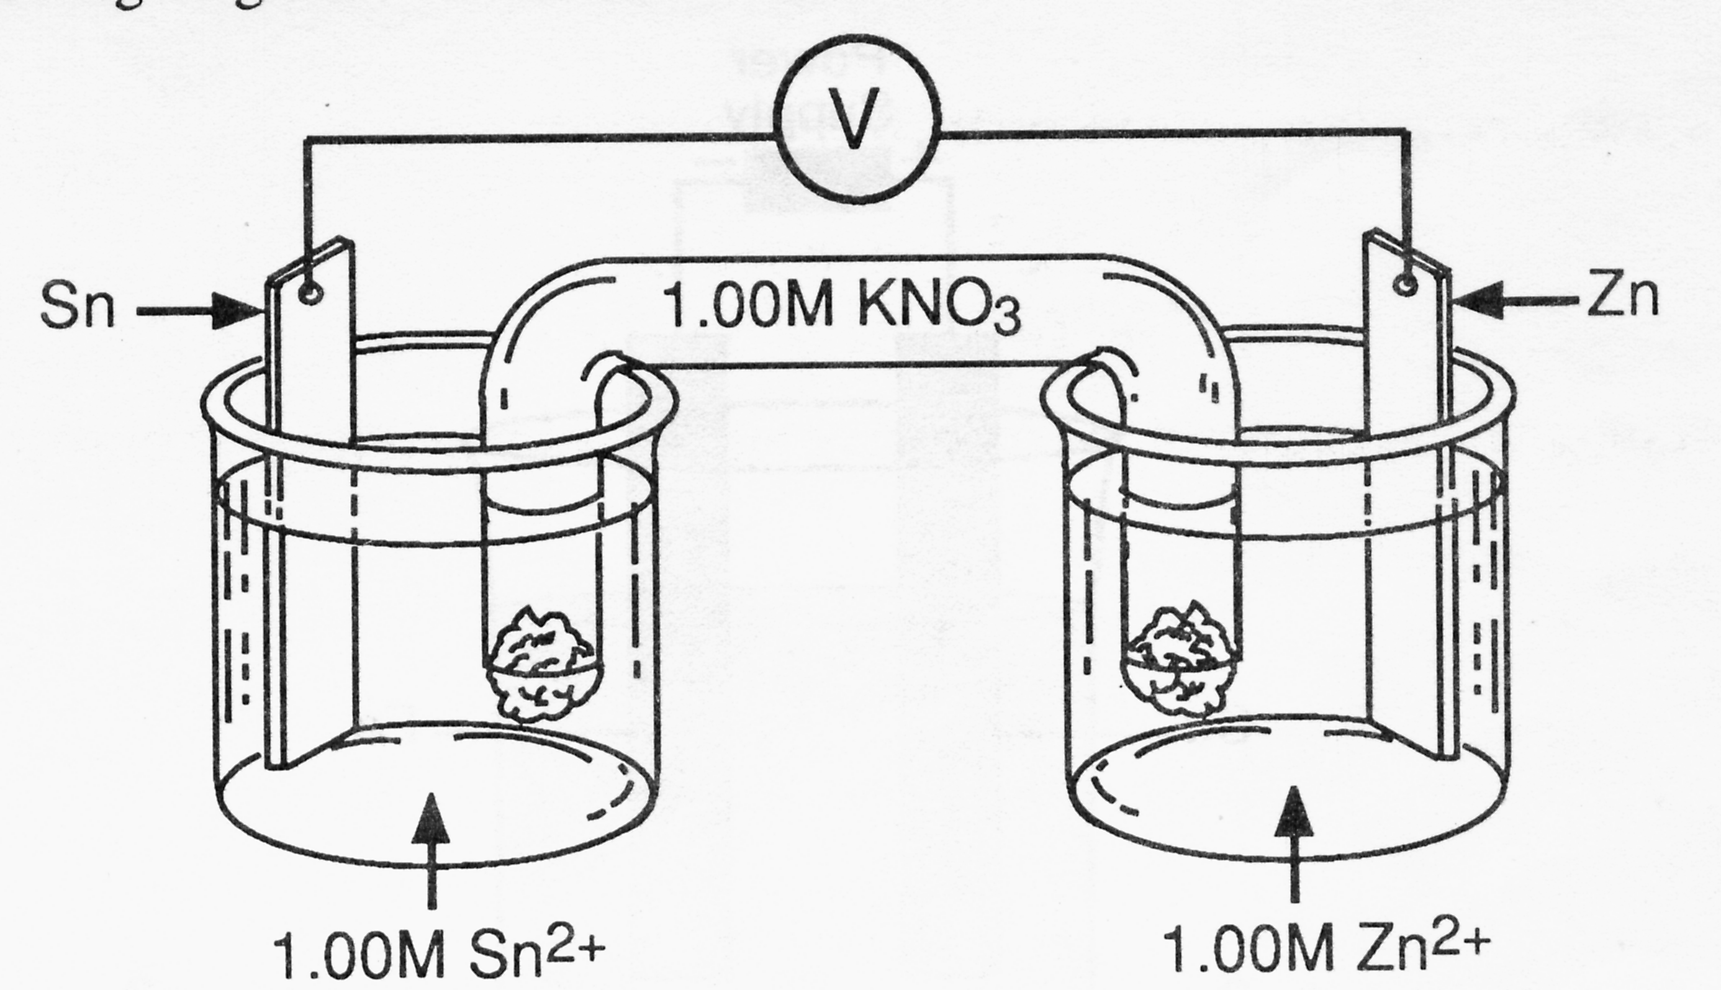
Pb
1M Al(NO₃)₃
Al
1M Pb(NO₃)₂

46. When the external circuit is completed in the above electrochemical cell at standard conditions, what is the reaction at the anode?

A. Al³⁺_{(aq)} + 3e⁻ → Al_{(s)}
B. Pb²⁺_{(aq)} + 2e⁻ → Pb_{(s)}
C. Al_{(s)} → Al³⁺_{(aq)} + 3e⁻
D. Pb_{(s)} → Pb²⁺_{(aq)} + 2e⁻

47. As the above cell continues to operate, the solution in the lead half-cell will

A. increase in [Pb²⁺] and [K⁺]
B. increase in [Pb²⁺] and decrease in [K⁺]
C. decrease in [Pb²⁺] and [K⁺]
D. decrease in [Pb²⁺] and increase in [K⁺]

48. How many grams of Ba are produced when 2.00 mol of electrons are used in the electrolysis of molten barium chloride?

A. 68.5 g
B. 71.0 g
C. 137 g
D. 275 g

49. Consider this redox equation:
BrO₃⁻ + 6H⁺ + 3Sb³⁺ → Br⁻ + 3Sb⁵⁺ + 3H₂O
Which of the following loses electrons?

A. H⁺
B. Sb³⁺
C. H₂O
D. BrO₃⁻

50. Consider the following redox equation:
10CO₂ + K₂SO₄ + 2MnSO₄ + 8H₂O → 2KMnO₄ + 5H₂C₂O₄ + 3H₂SO₄
The reducing agent in this reaction is

A. CO₂
B. H₂O
C. K₂SO₄
D. MnSO₄

51. At standard conditions, which of the following is the strongest oxidizing agent?

A. Ca
B. Cu²⁺
C. NO₃⁻ in acid
D. MnO₄⁻ in base

52. At standard conditions, Fe²⁺ reacts spontaneously with

A. I₂
B. Co
C. Br⁻
D. Ag⁺

53. What is the oxidation number of C in C₂O₄²⁻ ?

A. 0
B. 3+
C. 4+
D. 6+

54. Which of the following half-reactions is balanced?

A. 2NO₃⁻ + 2H₂O + 2e⁻ → N₂O₄ + 4OH⁻
B. 2NO₃⁻ + 2H₂O → N₂O₄ + 2e⁻ + 4OH⁻
C. 2NO₃⁻ + 4OH⁻ → N₂O₄ + 2H₂O + 2e⁻
D. 2NO₃⁻ + 4OH⁻ + 2e⁻ → N₂O₄ + 2H₂O

55. In an electrochemical cell, electrons flow from the

A. anode to the cathode through the salt bridge.
B. cathode to the anode through the salt bridge.
C. anode to the cathode through the external circuit.
D. cathode to the anode through the external circuit.

56. Given the following electrochemical cell:
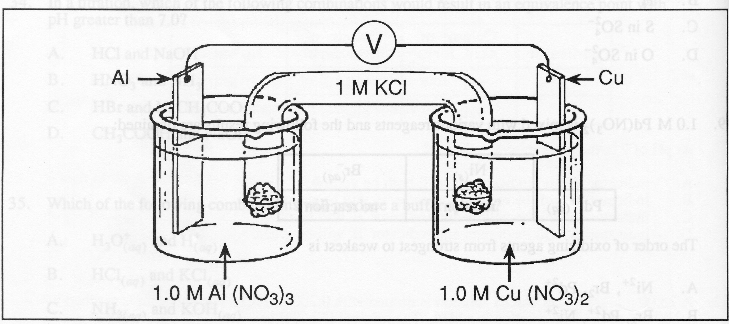

Co

Fe

1.00 M Co²⁺

1.00 M Fe²⁺

As this cell operates, the

A. mass of the Co electrode increases and the [Fe²⁺] increases.
B. mass of the Fe electrode increases and the [Co²⁺] increases.
C. mass of the Co electrode increases and the [Fe²⁺] decreases.
D. mass of the Fe electrode increases and the [Co²⁺] decreases.

57. Which of the following redox equations represents a reaction in an electrolytic cell?

A. Cu²⁺ + Ni → Cu + Ni²⁺
B. Hg²⁺ + Ni → Hg + Ni²⁺
C. 2Ag⁺ + Ni → 2Ag + Ni²⁺
D. 2Al³⁺ + 3Ni → 3Ni²⁺ + 2Al

58. A material that provides cathodic protection for iron must

A. be more easily reduced than iron.
B. be more easily oxidized that iron.
C. be a better oxidizing agent than iron.
D. have a more positive standard reduction potential (E°) value than iron.

59. Given this electrolytic cell:
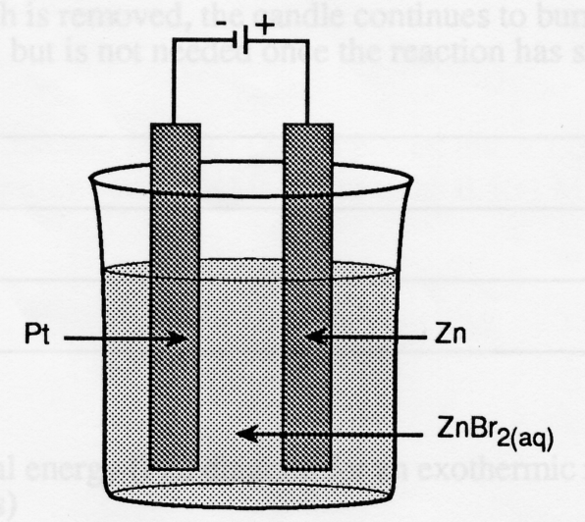

The reaction which takes place at the anode is

A. Zn → Zn²⁺ + 2e⁻
B. Zn²⁺ + 2e⁻ → Zn
C. Br₂ + 2e⁻ → 2Br⁻
D. 2H₂O → O₂ + 4H⁺ + 4e⁻

60. An aqueous solution contains Na⁺ , Ni²⁺ , Zn²⁺ , and Cu²⁺ . Which ions can be extracted by electrolysis of the solution?

A. Na⁺ , Zn²⁺ , Ni²⁺
B. Cu²⁺ , Ni²⁺ , Na⁺
C. Zn²⁺ , Na⁺ , Cu²⁺
D. Ni²⁺ , Cu²⁺ , Zn²⁺

61. If a substance has lost electrons it

A. has been reduced.
B. has been oxidized.
C. has acted as a cathode.
D. has acted as an oxidizing agent.

62. A student investigating redox reactions recorded the following results:
V²⁺ + Te²⁻ → no reaction
U⁴⁺ + Te²⁺ → U³⁺ + Te
Based on these results, the strengths of the oxidizing agents, arranged from strongest to weakest, are

A. V²⁺, Te, U⁴⁺
B. U⁴⁺, Te, V²⁺
C. U³⁺, Te²⁻, V²⁺
D. V²⁺, Te²⁻, U³⁺

63. Some S₂O₈²⁻_{(aq)}, SO₄²⁻_{(aq)}, Cu²⁺_{(aq)} and Cu_{(s)} are placed in a container at standard conditions. Which of the following equations represents the predicted spontaneous reaction that would occur?

A. 2SO₄²⁻ + Cu→ S₂O₈²⁻ + Cu²⁺
B. S₂O₈²⁻ + Cu → 2SO₄²⁻ + Cu²⁺
C. S₂O₈²⁻ + Cu²⁺ → 2SO₄²⁻ + Cu
D. 2SO₄²⁻ + Cu²⁺ → S₂O₈²⁻ + Cu

64. Consider this redox equation:
C₂O₄²⁻ + MnO₂ → Mn²⁺ + 2CO₂
As a result of this reaction the oxidation number of each C atom has

A. increased by 1.
B. increased by 2.
C. decreased by 2.
D. decreased by 4.

65. When W₂O₅ is converted to WO₂ in a redox reaction, the W has been

A. reduced since its oxidation number has increased.
B. reduced since its oxidation number has decreased.
C. oxidized since its oxidation number has increased.
D. oxidized since its oxidation number has decreased.
66. Consider the following diagram of an electrochemical cell:
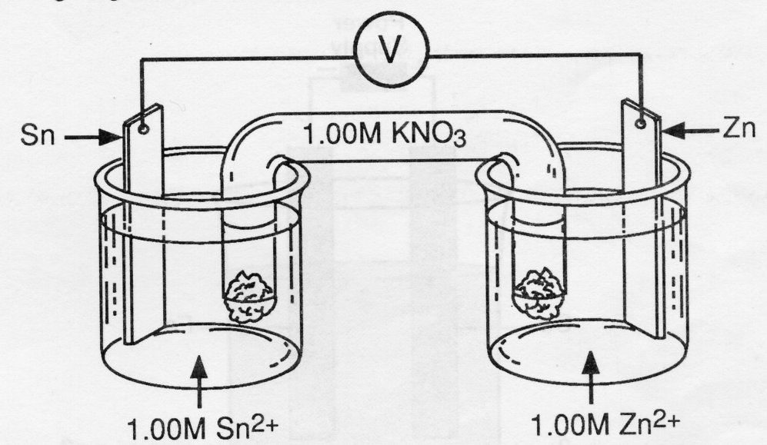

The reaction that takes place at the anode is

A. Sn → Sn²⁺ + 2e⁻
B. Zn → Zn²⁺ + 2e⁻
C. Sn → 2e⁻ + Sn
D. Zn²⁺ + 2e⁻ → Zn

67. A student wants to determine the [Sn²⁺] in a solution of SnCl₂ by a redox titration. A suitable ion to use would be

A. Br⁻
B. Cr³⁺
C. Pb²⁺
D. MnO₄⁻

68. Which of the following metals could be used to make a container in which to store NiCl₂ solution without a reaction occurring?

A. Cr
B. Pb
C. Co
D. Mn

69. When a metal undergoes corrosion, it

A. loses electrons.
B. becomes reduced.
C. acts as an oxidizing agent.
D. decreases in oxidation number.

70. Consider the following diagram of a chemical cell:
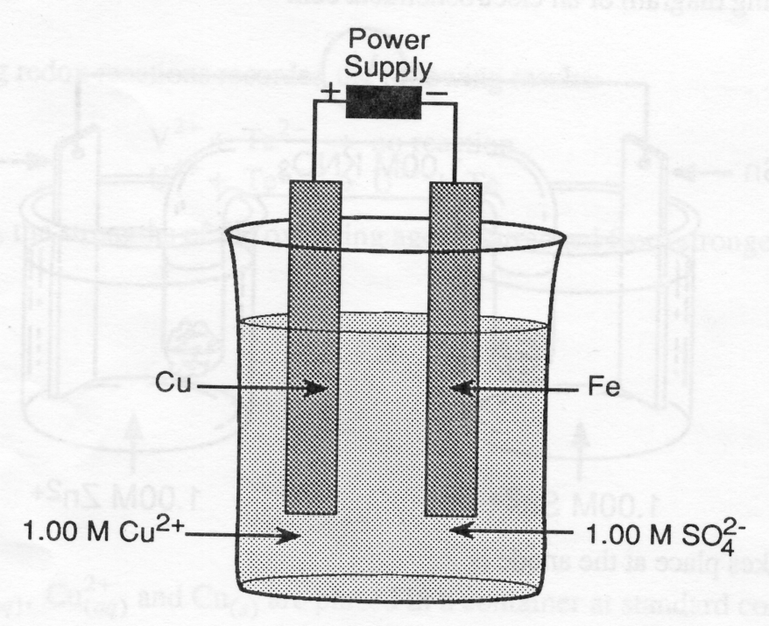

If this cell operates as an electrolytic cell to plate Cu onto Fe, which of the following acts as the anode?

A. Cu
B. Fe
C. SO₄²⁻
D. Cu²⁺

71. When electrolysis of molten Al₂O₃ is carried out, which of the following reactions will occur at the cathode?

A. 2O²⁻ → O₂ + 4e⁻
B. Al³⁺ + 3e⁻ → Al
C. Al₂O₃ → 2Al³⁺ + 3O²⁻
D. 2H₂O + 2e⁻ → H₂ + 2OH⁻

