WRITTEN RESPONSE QUESTIONS:

Your steps and assumptions leading to a solution must be shown clearly. Full marks will not be awarded for a final answer only. In written response questions involving explanation, students will be expected to communicate the knowledge and understanding of chemical principles in a clear and logical manner (poorly worded, hazy abstractions will not be awarded full marks.)

1. Balance the following half-cell reaction in basic solution : (2 marks)

Cr3+ CrO42- (basic)

2. Work out the balanced overall redox equation for the reaction shown below in basic solution.
(3 marks)
Co2+ + OCl– Co(OH)3 + Cl– (basic)

3. Examine the following electrochemical cell operating at 25oC.

a) When the switch is closed, what will be the reading on the voltmeter? (1 mark)
b) Which metal strip will become the cathode ? (1 mark)
c) At which metal strip will oxidation occur? (1 mark)
d) Write the formula(s) of the ion(s) migrating to the lead half-cell. (1 mark)
e) When the cell reaches equilibrium, what will the voltage be ? (1 mark)

4. An electrochemical cell is constructed with a zinc electrode in Zn(NO3)2 solution and an aluminum electrode in Al(NO3)3 solution. The two solutions are connected by a salt bridge. Identify the anode and state the reason for your choice. Support your answer by giving the
half-reactions and the oxidation potentials for the oxidation of zinc and aluminum. (4 marks)

5.

a) Write the cathode half-reaction for the above cell. (1 mark)
b) Describe the flow of electrons and cations in the above cell. Identify both the
direction and the pathway. (2 marks)
c) Describe the function of the salt bridge in the above cell. (1 mark)

6. Write a balanced equation for the reaction between C2O42- (aq) and MnO4-(aq) in an acidic solution to yield CO2 (g) and Mn2+(aq). (3 marks)

7. Define reducing agent. (1 mark)

8. Balance the equation for the following redox equation : (3 marks)
MnO4-(aq) + SO2 (g) Mn2+(aq) + SO42-(aq) (acidic)

9. Balance the following oxidation-reduction equation : (3 marks)
N2O (g) + ClO-(aq) Cl-(aq) + NO2-(aq) (acidic)

10. Balance the equation for the following reaction in an acidic solution : ( 3 marks)
Cu (s) + NO3-(aq) Cu2+(aq) + NO (g)

11. Describe how to plate zinc on an iron nail by using an electric current. (3 marks)

12. Write a balanced equation for the following reaction which occurs in a basic solution.
(3 marks)
MnO4-(aq) + I-(aq) MnO2 (s) + I2 (s)

13.

a) Give the oxidation-reduction equation for the above cell. (1 mark)
b) Calculate the initial cell voltage. (1 mark)
c) Describe what happens in the salt bridge when the cell is operating. (2 marks)

14. How does an electrochemical cell reaction differ from an electrolytic cell reaction ? (2 marks)

15. A neutral solution of KI was electrolyzed to give H2 and I2.
a) Write the anode half-reaction. (1 mark)
b) Write the cathode half-reaction. (1 mark)
c) What is the theoretical minimum voltage required ? (1 mark)

16. Use the following illustration to answer question 16 :

The overall cell reaction in this dry cell when operating is given by :
Zn (s) + 2MnO2 (s) ZnO (s) + Mn2O3 (s)

a) What substance is oxidized at the anode ? (1 mark)
b) What substance is reduced at the cathode ? (1 mark)
c) At equilibrium, what is the voltage of the dry cell ? (1 mark)

17. The redox reaction that occurs between Fe2+ and Cr2O72- in acid solution is as shown below :

6Fe2+ + Cr2O72- + 14H+ 6Fe3+ + 2Cr3+ + 7H2O

When 20.0 mL of an Fe2+ solution of unknown concentration was titrated with a
0.0200 M Cr2O72- solution, the following data were obtained :

initial reading 1.42 mL
final reading 16.42 mL
volume of Cr2O72- solution used 15.00 mL

Calculate the [Fe2+] of the original solution. (3 marks)

18. Write a balanced equation for the following reaction which occurs in a basic solution.
MnO₄⁻_{(aq)} + I⁻_{(aq)} → MnO_{2(s)} + I_{2(s)} (basic) (3 marks)

19. A neutral solution of KI was electrolyzed to give H₂ and I₂.

a) Write the anode half-reaction. (1 mark)
b) Write the cathode half-reaction. (1 mark)
c) What is the theoretical minimum voltage required? (1 mark)

20. Consider the following redox equation:

4CrO₄²⁻ + 3Cl⁻ + 20H⁺ → 4Cr³⁺ + 3ClO₂⁻ + 10H₂O
Write the balanced oxidation half-reaction equation. (3 marks)

21. Define the term “reduction.” (1 mark)

22. Balance the following redox reaction occurring in basic solution: (4 marks)
CrO₂⁻ + S₂O₈²⁻ → CrO₄²⁻ + SO₄²⁻

23. Given the following diagram of a cell, which is constructed in order to determine the reduction potential of a Cd half-cell:
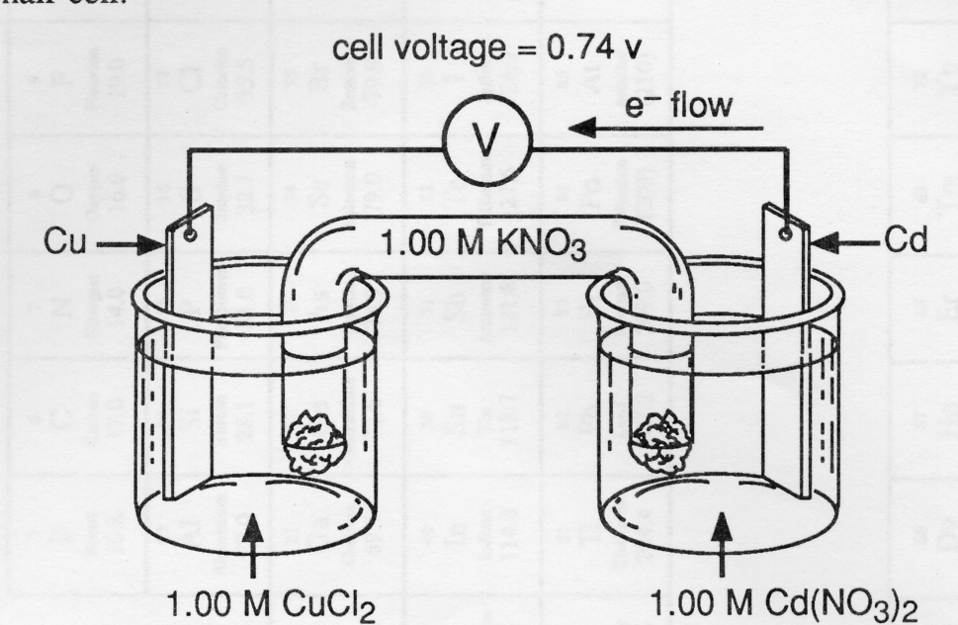

a) Identify the cathode in the cell. (1 mark)
b) Write the half-reaction occurring at the Cd electrode. (1 mark)
c) Determine the E° for the half-reaction, Cd²⁺ + 2e⁻ → Cd. (1 mark)

Answers

Multiple Choice:

1. C
2. A
3. D
4. D
5. D
6. B
7. A
8. B
9. D
10. C
11. A
12. B
13. C
14. D
15. C
16. D
17. A
18. C
19. C
20. C
21. B
22. B
23. A
24. B
25. A
26. A
27. A
28. B
29. A
30. D
31. A
32. D
33. B
34. C
35. B
36. C
37. D
38. A
39. D
40. C
41. B
42. C
43. D
44. A
45. B
46. C
47. D
48. C
49. B
50. D
51. C
52. D
53. B
54. A
55. C
56. A
57. D
58. B
59. A
60. D
61. B
62. B
63. B
64. A
65. B
66. B
67. D
68. B
69. A
70. A
71. B

Written responses :

1. Cr3+ + 8OH- CrO42- + 4H2O + 3e-

2. 2Co2+ + 4OH- + OCl- + H2O 2Co(OH)3 + Cl-

3. a) 0.93 volts
b) silver
c) lead
d) NO3-
e) 0.00 volts

4. Zn Zn2+ + 2e- 0.76 V
Al Al3+ + 3e- 1.66 V
Aluminum is more easily oxidized therefore it becomes the anode.

5. a) Ag+ + e- Ag
b) Electrons flow from the zinc electrode to the silver electrode via the wire.
Cations flow towards the silver electrode via the solution and the salt bridge.
c) It provides a path for the migration of ions from one half cell to the other.

6. 16H+ + 2MnO4- + 5C2O42- 2Mn2+ + 10CO2 + 8H2O
7. A substance which causes another substance to gain electrons (become reduced).

8. 2H2O + 2MnO4- + 5SO2 2Mn2+ + 5SO42- + 4H+

9. H2O + N2O + 2ClO- 2NO2- + 2H+ + 2Cl-

10. 3Cu + 8H+ + 2NO3- 3Cu2+ + 2NO + 4H2O

11. Connect iron nail to negative terminal of an electrochemical cell (to serve as a source of electrons). Connect positive terminal to a zinc rod. Place both the nail and rod in a beaker containing a solution of Zn(NO3)2. Zinc will be plated on the nail and zinc rod will lose mass. [Zn2+] in the solution will remain relatively constant.

12. 4H2O + 2MnO4- + 6I- 2MnO2 + 3I2 + 8OH-

13. a) Ni2+ + Zn Zn2+ + Ni
b) 0.51 V
c) K+ ions migrate towards the nickel electrode while NO3- ions migrate towards the zinc electrode. Both these migrations help to keep the solutions in the beakers of each half cell electrically neutral.

14. In electrochemical cells, spontaneous chemical reactions occur resulting in a decrease in the chemical energy of the system. In electrolytic cells, nonspontaneous reactions occur by adding electrical energy and the system undergoes an increase in potential energy.
or
In an electrochemical cell the reaction is spontaneous and produces a voltage as it proceeds.
In an electrolytic cell the reaction is nonspontaneous and requires an applied voltage to proceed.

15. a) 2I- I2 + 2e-
b) 2H2O + 2e- H2 + 2OH-
c) 1.36 V

16. a) Zn
b) MnO2
c) 0.00 V

17. 0.0900 M

18. [2× (MnO₄⁻ + 4H⁺ + 3e⁻ → MnO₂ + 2H₂O)]

+ [3× (2I⁻ → I₂ + 2e⁻)]
_____________________________________________________________________

2MnO₄⁻ + 8H⁺ + 6I⁻ → 2MnO₂ + 4H₂O + 3I₂

+ 8OH⁻ + 8OH⁻
______________________________________________________________________

2MnO₄⁻ + 4H₂O + 6I⁻ → 2MnO₂ + 8OH⁻ + 3I₂
19. a) 2I⁻ → I₂ + 2e⁻
b) 2H₂O + 2e⁻ → H₂ + 2OH⁻(10⁻⁷ M)
c) greater than +0.95 V

20. Cl⁻ → ClO₂⁻ (1 mark)

+2H₂O (1/2 mark)
+4H⁺ (1/2 mark)
+4e⁻ (1/2 mark)
_________________________________________________

∴ Cl⁻ + 2H₂O → ClO₂⁻ + 4H⁺ + 4e⁻ (1/2 mark)

21. Process in which e⁻ are gained by a species.
or
Process during which a species undergoes a decrease in oxidation number. (1 mark)

22. Half Reaction Method

2 × (CrO₂⁻ + 2H₂O → CrO₄²⁻ + 4H⁺ + 3e⁻)

+ 3 × (S₂O₈²⁻ + 2e⁻ → 2SO₄²⁻)
_________________________________________________________

2CrO₂⁻ + 4H₂O + 3S₂O₈²⁻ → 2CrO₄²⁻ + 8H⁺ + 6SO₄²⁻

+ 8OH⁻ + 8OH⁻
_________________________________________________________

2CrO₂⁻ + 8OH⁻ + 3S₂O₈²⁻ → 2CrO₄²⁻ + 4H₂O + 6SO₄²⁻

(1 mark for each half reaction, 1 mark for mole ratio, 1 mark for changing to basic)

(alternatively, change CrO₂⁻ half-reaction to basic first, giving:
CrO₂⁻ + 4OH⁻ → CrO₄²⁻ + 2H₂O + 3e⁻

23. a) Cu
b) Cd → Cd²⁺ + 2e⁻
c) E° for Cd → Cd²⁺ + 2e⁻ = 0.74 − 0.34 = 0.40 V
∴ E° for Cd²⁺ + 2e⁻ → Cd = −0.40 V

