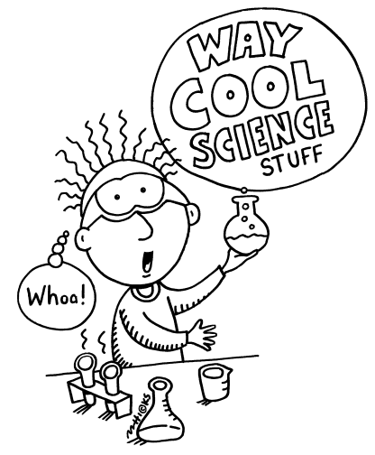Science Fair - 2012/2013

What is Science Celebration/Science Fair?
This is your opportunity to do an independent project on any topic in science that you choose. You will carry out the investigation and complete a report and display of your project. In February, the Science Fair will take place. The results of your investigation will be displayed and shared with the rest of the class, and marked by judges (teachers and senior students). The top projects from each class may be entered in the school “Science Fair”.

What kind of project can I do?
The topics are wide open. You can pick any branch of science from biology, chemistry, physics, engineering, inventions, to psychology. The main idea is for you to pick a question to investigate, set up an experiment that tests the question, and carry out the experiment. All of this will be recorded in a diary or log of your experiment. You will then write up the results, discuss your findings, make a conclusion, and make a stand-up display (see page 3 for details) that can be set up on a table.

More details ….
Projects may be done individually or in pairs.
The project will be worth 20% of your term 2 mark.

What makes a good investigation?
The main purpose of the Science Fair for grade 9/10 H is to learn the scientific method. A Science Fair project should examine a single question. The experiment must then follow the Scientific Method. Some of the investigations tried in the past include:
What kind of water should plants be watered with?
What brand of popcorn pops the best?
How does an oil spill affect bird feathers?
What kind of soap makes the best bubbles?
What shape boat works best?
What face cleaner kills bacteria best?
What kinds of sun block work best?

** If you are having difficulty coming up with an idea, your teacher can provide you with a list of possible projects, and there are several excellent resources in the school library.

What kind of research should I do?
It is important that you have plenty of background information on your project. This will allow you to design a good investigation and to answer any questions asked by judges. As well, you need to write a report on your experiment and include a bibliography (list of reference books, magazines and web-sites). You will get some library time to work on your project.

What makes a good experiment?
A good experiment:
- tests the question being asked, and only the question being asked
- has clearly defined independent variable and dependent variables
- has clear results
- has controls
- has results that can be measured
- has been done more than once to check the results
- can be easily repeated
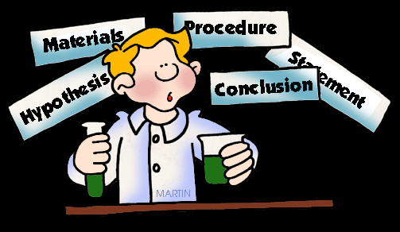What will the judges be looking for?

The Question
- is the question clear?
- is the question relevant?
- is the idea original?

The Experiment
- is it a controlled experiment? (can you identify the Independent and Dependent Variables? Which variables are controlled? What is the standard (control)?
- does it test for the question?
- are the results clear?
- could it be repeated?

The Presentation
- does the display clearly present the project?
- is it attractive?
- does it convey the necessary information?

The Report (minimum 3 pages)
- does the report accurately present the project?
- does it show the background research being done?
- does it have a bibliography?
- is the report well written and presented?
- can the students answer questions about their project?

The Report

Your report should be approximately 500 words, double-spaced on three pages. (Often, your report is longer that this!) Graphs and charts can be added to illustrate the main point of your report. The parts of the report are:

Question: What are you trying to find out?
Hypothesis: What do you predict the results will be and why?
Materials: What do I need to use for the experiment?
Procedure: How did you carry out your investigation?
Data and Observations: What information did you collect? What did you observe?
Results: Arrange the results of your experiment, using tables and diagrams where
possible.
Conclusions: What did you prove or disprove? What did you learn?
Bibliography: What kind of resources did you use to research your experiment? An instruction sheet for making a biography is available in the library.
Journal/Log: A detailed, week by week account of work on your science project.

The judges will examine your display and ask you questions on your project. They will be looking for:
Originality - in your ideas and in the approach you have taken.
Accuracy - have you set up a good experiment, are your results carefully measured and recorded?
Completeness - in carrying out the experiments and understanding what you have done. Has your experiment been repeated at least 3 times?
Results - did you end up with knowledge that is important to you?

The Display

Your exhibit should look like the one shown below.

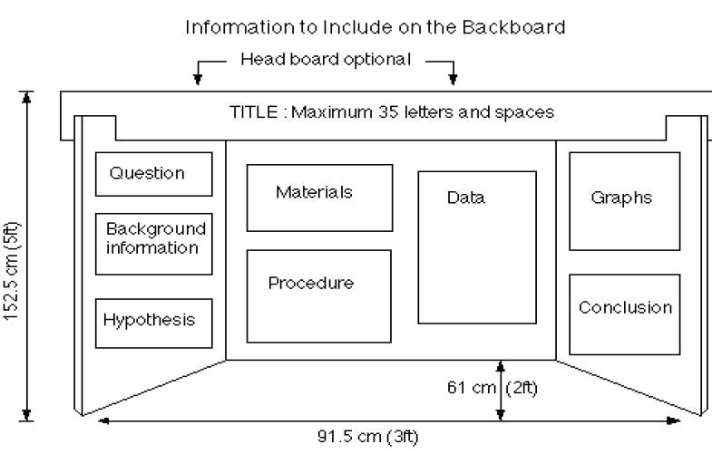

Doing a project that is worthwhile

There are different levels of science projects. At the high school level, projects must involve an investigation and some original research.

The minimum level required is a project that answers a question by designing an experiment that tests one or two variable factors. For example: study the rate of corrosion of metals under different temperatures and humidity levels.

A more sophisticated project is one that includes an experiment in which all possible variables are controlled, and where results cannot be attributed to error or variance and can be documented. This type of work will lead to more questions and further research possibilities.

Due Dates:
Date
Topic discussion with teacher Monday, Oct.15 (Goal Day)
Journals due each month Oct.30, Nov.23, Dec.17
Rough copy of written report due Jan 24
Project Discussion with teacher Jan 29 (Goal Day)
Final report due – presentation day Feb 6

Judging
Judging will happen on February 6. You need to be present at the Science Fair, which will occur in your regular science block. Judges will be senior science students. Part of the fun of a science fair is talking to the judges about your research. The judging process can be a good learning experience, particularly if you are interested in going to the regional science fair. Absence from class on this day must be prearranged with your science teacher. All teachers are also available to review scoring and re-judge a project if you feel you have been marked unfairly. The judges will examine your display and make comments on them.

Finalists Day
On February 20, we will have a Judging Day Finalists. If you are invited to the finalists judging, we will ask you to write an abstract for your project, and to attend a judging session that takes place in the Gallery. Judges that day will be science teachers, scientists from the community and former graduates studying science.

Ms. Shim’s Tips:
- When choosing a topic, choose something you are interested in and enjoy doing! For example, if you really like hockey, what kind of project could you do about hockey? About hockey equipment? Where could you get equipment (coach, community center, etc.)? Who could you ask for help (teammates, family members, etc.)?

- Make a schedule. For example, by the end of November, I want to have my background research completed and have all my materials collected.

- Ask questions!

- Don’t get discouraged. Ask for help when you need it.

- To do a good project, it will take time and effort. Projects done at the last minute are obvious to spot. The judges know you have had almost 5 months to work on your project and want to see your creativity and effort.

- Have fun! Working with a partner can have its challenges, but you may also find a best friend at the end.
Scientific Method

For this project you may design and perform a “controlled experiment”, testing one or two variables.

- You must choose a question that you are curious about. It must be the kind of question that can be answered by doing a scientific experiment, and have measurable results.

- You must make a list of all the variables that might have an impact on your results.

- Decide which variables need to be controlled. What will you keep constant for all trials, and what will you change?

- Is there a standard value (a control) that your results should be compared to?

- Decide what measurements you will need to take and record. Set up an system for organizing your data (e.g. data tables, charts, lists, diagrams)

- Decide on your experimental steps and write them down in fine detail, in an organized way. The steps should be written so clearly that someone else could follow them just by reading. You may find that using diagrams as well as words helps make the steps more clear.

- Do a test run. Try the experiment once, and pay close attention to difficulties in performing the experiment, in taking measurements, or in interpreting the results. Take this opportunity to make improvements to the experimental steps to solve any unexpected problems (write your observations and ideas for changes in your journal).

- For most experiments, there should be at least three trials (perform the experiment three times, to check for consistency of results). Your final results will be the average of the three trials.

- Lab Journal: While you perform the experiment you must keep records in a lab notebook. Record all your data, measurements, observations, diagrams of the equipment and how it’s set up, and any other observations or things that you noticed.
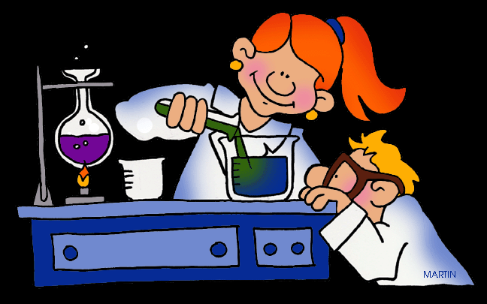
Science Fair – Research Proposal
Name: __________________________ Block: _____________
Name: __________________________ Due: Nov.7

1. What general topic area are you interested in exploring?

_________________________________________________________________
_________________________________________________________________
_________________________________________________________________
2. Identify the problem you would like to investigate. What is you research question?
____________________________________________________________________________________________________________________________________________________________________________________________________________________________________________________________________

3. State a hypothesis for your investigation: (I believe that …)
____________________________________________________________________________________________________________________________________________________________________________________________________________________________________________________________________

4. Will you need after-school time to use the school lab equipment to carry out your experiments? Give details.
__________________________________________________________________________________________________________________________________
__________________________________________________________________________________________________________________________________

5. Write down the resources you have used during this class to help you determine your experiment and what references you will use:
____________________________________________________________________________________________________________________________________________________________________________________________________________________________________________________________________
_________________________________________________________________
_________________________________________________________________
- If you are doing an experiment: Describe the experimental procedure that you plan to carry out in order to test your hypothesis. Identify the VARIABLES in your experiment, and give a timeline of when you will carry them out. If you plan to make an invention, describe its purpose and how you plan to make it.
OR
If you are doing an invention: Describe the invention that you plan to make or study. Identify the purpose and goals of your project – what do you hope to achieve? Describe the purpose of the invention and how you plan to make it.

____________________________________________________________________________________________________________________________________________________________________________________________________________________________________________________________________
____________________________________________________________________________________________________________________________________________________________________________________________________________________________________________________________________
__________________________________________________________________________________________________________________________________
__________________________________________________________________________________________________________________________________
____________________________________________________________________________________________________________________________________________________________________________________________________________________________________________________________________
_________________________________________________________________
_________________________________________________________________
_________________________________________________________________
_________________________________________________________________
_________________________________________________________________
_________________________________________________________________
_________________________________________________________________
_________________________________________________________________
_________________________________________________________________
_________________________________________________________________
_________________________________________________________________
_________________________________________________________________
_________________________________________________________________
_________________________________________________________________
_________________________________________________________________
_________________________________________________________________

